**Set 1**

1. Choose 2 paintings by Ravi Varma and appreciate them from an art critic’s viewpoint in about 100 words.
2. Gather relevant facts about Mysore and Tanjore paintings and answer the following questions. Each question contains 5 marks:
3. Write a brief History of Mysore Paintings.
4. What is the process involved in making Mysore paintings?
5. Write the unique feature of Tanjore paintings.
6. Explain the procedure of Tanjore paintings.

**Set 2**

1. Collect the images (one for each) for the following kinds of Indian traditional paintings and label them. Paste the images in the space provided below. Adjest the size of your images accordingly.

Madhubani – Rajput – Kalamkari – Pattachitra – Warli

1. Observe the following images carefully and write a paragraph (200 words) on how folk art plays crucial role in the lives of common man in India.

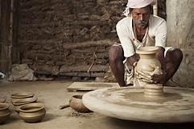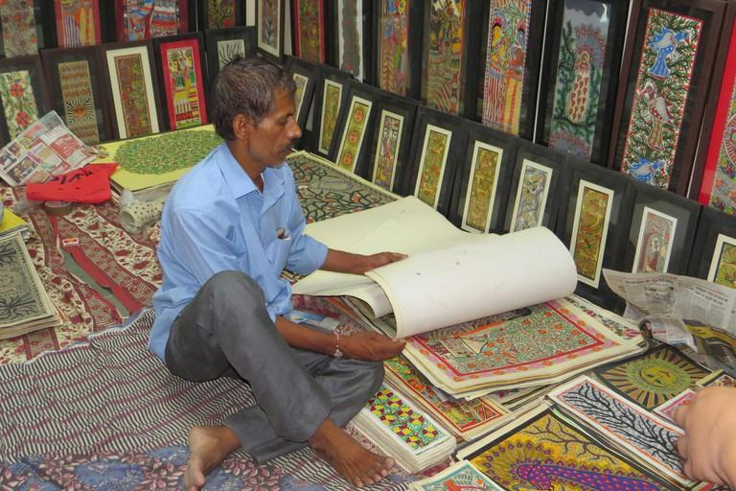

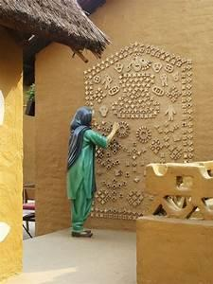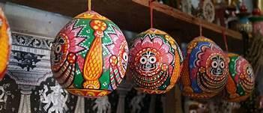Image 3 (Source: https://images.search.yahoo.com/search/images)

**Set 3**

‘Mughal used different themes to make their miniatures or paintings such as legendary stories, wildlife, royal life, hunting scenes, battlefield, Muslim mythology and more. And the best part of these paintings is that they have now become the main medium to describe the tales of the Mughal Empire’. Discuss how these paintings were not just paintings but an art of storytelling in about 500 words. Paste relevant pictures along with your write up. (20 marks)